**Use Dashboard Nodes for Creating UI (Web Apps)**

|  |  |
| --- | --- |
| **Team Id** | PNT2022TMID19409 |
| **Project Name** | Smart Waste Management System for Metropolitan Cities |

Step 1: Launch Node Red and drag and drop blocks according to the Python script flow.

Step 2: Ensure tha

**Node Red Flow**

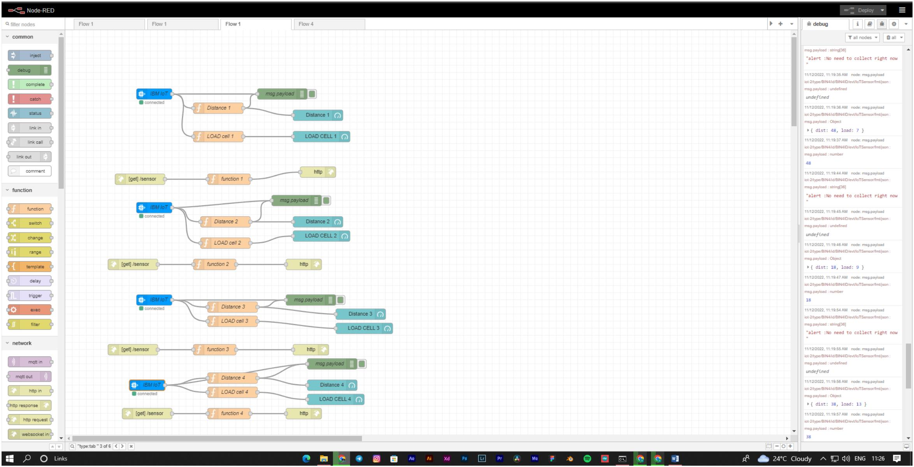

**Node Red UI**

